**1. Proposed Profile: *Device Observation Semantic Bridge (DSB/DOSB)***

* Sponsor: *VHA*
* Proposal Editor: *Alex Lippitt*
* Profile Editor: *Ioana Singureanu*
* Other Contributors: *Greg Staudenmaier; Paul Schluter; Loren Stevenson, MD*
* Domain: *submitted to both PCD and PCC*

**The Problem**

Getting semantically correct data from patient care devices into clinical applications is difficult for a number of reasons:

* + The applicable nomenclature from medical devices, IEEE 11073 10101, is not one of the Meaningful Use approved nomenclatures, reducing the incentive to use IEEE 11073 data in clinical applications
  + There are no commonly accepted mappings of IEEE 11073 10101 to Meaningful Use approved nomenclatures (LOINC and SNOMED primarily) for clinical measures although there are vendors who have done so as proprietary interfaces
  + There are still many circumstances where the specific numeric measures are not codified in a generally accepted standard, for example the current work with ventilators
  + There are no good filtering standards to drive constraining device streams to be usable by clinical applications

The result is that much of this numeric data generated from medical data is either not reentered into clinical systems or reentered at significant risk of error. This particularly impacts inpatient settings, but also to a lesser extent ambulatory and self-care devices.

**Scope and Goals**

The initial scope of work would include the following deliverables to build a foundation standards and an initial model for device and clinical application interoperability:

* Clinical content consists “Device numeric export” for vital signs mapped to LOINC and SNOMED
* Related alerts and events
* Saving of the device numeric export for vital signs messages in an accessible repository
* Basic configuration commands for the Device Observation Filter to manage:
  + Configuration of requested data streams
  + Subscription to data streams
  + Query’s for data

Ecosystem goals include:

* Obtain approval to include this standard as a gap closer in the ONC Interoperability Roadmap
* Obtain approval for IEEE 11073 10101 to be recognized as an MU approved nomenclature/vocabulary Prove acceptance of a certain set of IEEE data; Obtain approval to add an MU 3 requirements requirement for hospitals and ambulatory clinics to use this standard to obtain vital signs from medical devices, with incremental (stretch goal)

**Scope Constraints**

The proposed scope of the work is constrained by the following:

* Principles
  + Avoid semantic transformation where possible; work with both nomenclatures to align terminology and value sets with each other (include whole chunks of 11073 10101 nomenclature where possible) – needs to merge into clinical realm - a lot of work done
  + Use post-coordinated SNOMED concepts where possible to reduce the number of concepts that need to be created and managed; where necessary based on the IEEE 11073 10101 input
    - * + Map pre-coordinated concepts and deal with multiple axes
        + Deal with multiple axes for complex concepts
  + Establish an on-going process to ensure device / clinical harmonization over time involving IEEE, IHE, and NLM
* Scope Deferred
  + Use cases beyond inpatient vital signs, events and alerts
  + Usage with consumer devices
  + Usage with portable lab devices

**2. Cost Benefit**

Benefits of the Device Observation Semantic Bridge (DSB/DOSB ) integration would include:

* Improved workflow: Medical device data desired for clinical, operations, clinical quality improvement, population and research purposes could be requested retrospectively or subscribed in advance for publishing to a repository or to a specific clinical application for a specific patient and intervention.
* Improved data collection: Data would no longer need to be reentered from the device to the clinical application, effectively eliminating risks of neglecting to implement the data or making transcription errors.
* Improved safety: Increased observation data would be
* Improved patient care: Increased observation data would be included in the patient’s chart as well as in near real time for the clinical application for clinical decision support.

In the short term the benefits would apply to a high volume of work including any inpatient scenario involving devices providing vital sign observations. This would only increase over time as outpatient and patient settings are added and observations are added beyond vital signs.

Vital signs benefits of course do not apply to those vital signs that are observed manually such as height.

**3. Key Use Case**

In this initial phase the scope will include only the inpatient use case (ICU, Step Down, Observation, General / Surgical)

In which the patient is transported to a room and monitors are attached which one include one or more of the following:

|  |  |
| --- | --- |
| **Device** | **Clinical Data (Typical)** |
| Smart Bed | Weight with Alerts |
| Physiologic Monitoring | Vital Signs with Alerts |
| Pulse Oximeter (if needed – may  Be covered by the Physiologic Monitoring device) | O2 % BldC Oximetry  with Alerts |

Actors include:

DOB (Device Observation Bridge) – new

DOC (Device Observation Consumer

DOF (Device Observation Filter)

DOR (Device Observation Reporter)

Key steps include:

1. Configuration for Device DOF/DOB – stream and timing scope, auto push / pull mode requirements
2. Device sends data to DOR
3. DOR sends observation stream to DOF;
4. DOF filters stream to retain what is useful for retrospective work and stores filtered stream in Device Operations Repository; minimally includes alerts in initial phase
5. DOB maps clinical observations from filtered HL7 v2.6 messages to C-CDA and applies data transformations required for LOINC and SNOMED nomenclatures
6. DOB sends stream to Device Observation Clinical Repository, for storage
7. Repositories a) trigger availability notification to applicable DOC or b) DOC auto pushes depending on configuration
8. DOCs query streams as appropriate

**4. Standards & Systems**

Nomenclatures / Terminologies Used:

* Device (IHE PCD Technical Framework Volume 3 – Semantic Content)
  + IEEE 11073 10101 Nomenclature
  + MDC terms
* Clinical (HL7 Implementation Guide for CDA R2: IHE Health Story Consolidation, DSTU R1.1)
  + LOINC (observations)
  + SNOMED (constraints primarily)
* Device Information Model (DIM) – how a device maps to a hierarchical, containment tree model – GMDN. MDNS assumed in use but being phased out

HIT Detail:

* *Messaging*
  + *HL7 V2.6 constrained by IHE DEC PCD-01 and RTM – Device Operations*
  + *Consolidated CDA, IHE Health Story Consolidation, DSTU R1.1* - Clinical Observations*

* Message Transport
  + *Minimum Lower Layer Protocol (MLLP) over TCP/IP – Device Operations*
  + *Web Services(REST/SOAP) - Clinical Observations*

* Systems Impacted
  + *EHRs primarily currently*
  + *Over time: Clinical Decision Support, Population Management, Clinical Research*

*\* FHIR impact likely*

**5. Technical Approach**

**Existing related actors and workflow**

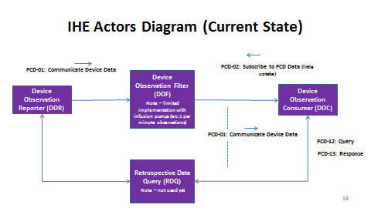

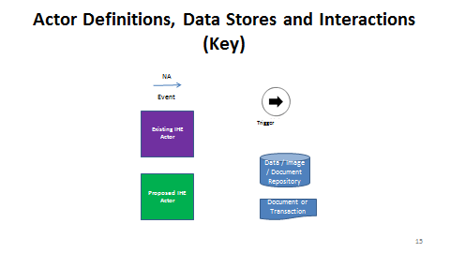

**Proposed actors, workflow, and data-related artifacts**

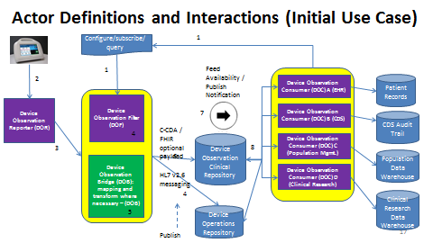

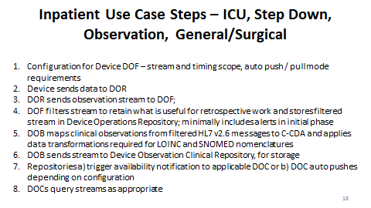

**Existing actors**

* Device Observation Consumer (DOC);add functions to PCD-02:
  + Configure
  + Subscribe
  + Generate pull queries (retrospective data)
* Device Observation Filter; enable:
  + Configure
  + Subscribe
  + Respond to pull queries

**New actors**

Data Observation Bridge (DOB)

* As constrained by PCD-02 Configure functions, generate data streams to be used by clinical applications: Consolidated CDA for IEEE 11073 10101 transformed/remapped data

**Existing transactions**

PCD-01 Communicate Device Data

* Add mapping to Consolidated CDA
* Add data transforms where needed
* Identify segments of untransformed data to send as is currently using HL7 v2.5 and v2.6

PCD-02 Configure, and Subscribe to PCD Data – originally conceived to be Subscribe Only (used rarely)

* Subscribe to specific device data streams
* Define subsets of data types to send
* Define appropriate instance intervals
* Pull specific device data streams
* Configure notifications for data streams
* Configure pass thru auto-triggers

**New Transactions**

TBD (may need to break up PCD-02)

**Impact on existing integration profiles**

1. PCD IHE International Integration Profiles for device interoperability with external systems
   * DEC – Device Enterprise Communication – extensions for semantic interoperability
   * ACM – Alert Communication Management – none known
   * DEC-SPD – Subscribe to Patient Data – needs to be built and extended for configuration and query
   * Device-specific Integration Profiles for implantable cardiac devices, infusion pumps and pulse oximetry -only pulse oximetry could be impacted in the first phase
2. Consolidated CDA – not a profile – may require extensions to the Vital Signs template

**New integration profiles needed**

N/A for now

**Breakdown of tasks that need to be accomplished**

Key content tasks:

1. Modify the DEC integration profile to extend capabilities for realistic usage by clinical applications in a plug and play environment to the extent possible
2. Find a home for the data mapping and transformation needed to bring semantically compatible device data into clinical applications; Develop a procedure and obtain commitment to that procedure from IEEE and IHE PCD to identify changes in the applicable nomenclatures and update mappings to reflect them
3. Conduct the mapping for the initial inpatient vital signs use case
4. Define filtering and configuration of data stream requirements

SME driven deliverables:

1. Data mapping into Consolidated – CDA
2. Extension of vital sign template to contain additional vital signs as required; determination of whether these will be device generated or data entered
3. Data transformation from IEEE 11073 10101 into LOINC and SNOMED nomenclatures where required
4. Definition of filtering and configuration appropriate for near real time and retrospective data uses

**6. Support & Resources**

**Collaborators (Phase 1)**

* IHE International - Standards Integration Profile Development
* C4MI – Mapping and Technical Support
* NLM – Mapping with subcontracts to IHTSDO and Regenstrief Institute as appropriate
* ONC – Endorsement Support / Inclusion in Roadmap - desired
* IHE USA – Project Management / Secretariat

**7. Risks**

* Inability to accurately transform certain vital signs from device to clinical system
* Solution additionally burdens clinician and/or system workflow

**8. Open Issues**

| **Section** | **Num** | **Issue / Challenge** | **Discussion / Resolution** |
| --- | --- | --- | --- |
| 1 | 1 | Should this be a whitepaper or trial implementation proposal? |  |
| 1 | 2 | Should this be for PCD or PCC or ITI? Or split? Is this potentially a DEC change proposal? |  |
| 1 | 3 | Where will the IEEE 11073 10101 to SNOMED and LOINC mappings be maintained? NIST Rosetta? NLM VSAC? Through an IHE created “Standard Terminology Services” utility? |  |
| 3 | 1 | Does the use case make sense? |  |
| 3 | 2 | What vital sign observations need to be added to the standard Consolidated CDA? |  |
| 5 | 1 | Should the standard be set up to provide the following transport options?   * MLLP * REST * SOAP |  |
| 5 | 2 | To what extent can this be plug_and_play?   * Will there be a service to permit real or near real-time data mapping and semantic transformation where required? * Will the mappings be available in machine readable form? * Will mappings be available in some form such that vendors can take advantage of their rich mapping utilities |  |
| 5 | 3 | Where will the “source of truth” mappings / data transformations be housed:   * RTMMS * VSAC * Other Option? |  |
| 5 | 4 | How will the mappings and data transformations be maintained? |  |
| 5 | 5 | How much work will it take? |  |

**9. Tech Cmte Evaluation**

*<The technical committee will use this area to record details of the effort estimation, etc.>*

Effort Evaluation (as a % of Tech Cmte Bandwidth):

* 35% for ...

Responses to Issues:

*See italics in Risk and Open Issue sections*

Candidate Editor:

TBA